**Experiment 2.1**

**Aim/Overview of the practical:**

* How to deploy a web application by using Microsoft Visual Studio on Azure portal?

**Code/Steps for the Practical:**

**Step 1)** Create a Static web app/page on your local machine using Microsoft Visual Studio which you want to deploy on Azure Portal.

**Step 2)** Open Microsoft Visual Studio click on Create new Project.

**Step 3)** In Create new Project window select **“ASP .NET Core Web App”**.

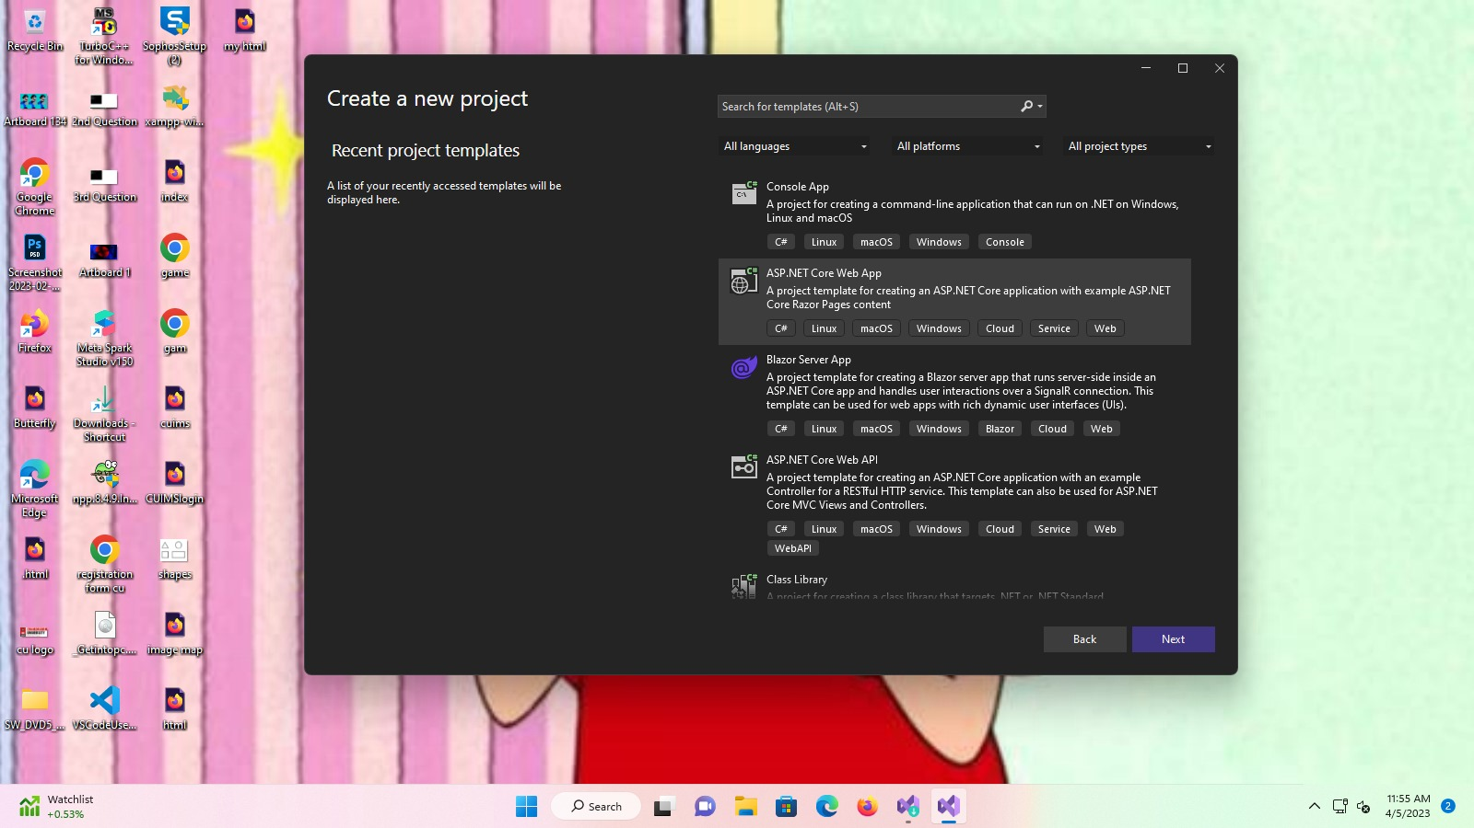

**Step 4)** Then on Configure your new Project window Enter Project related details like name of project, path of project and Framework type etc.

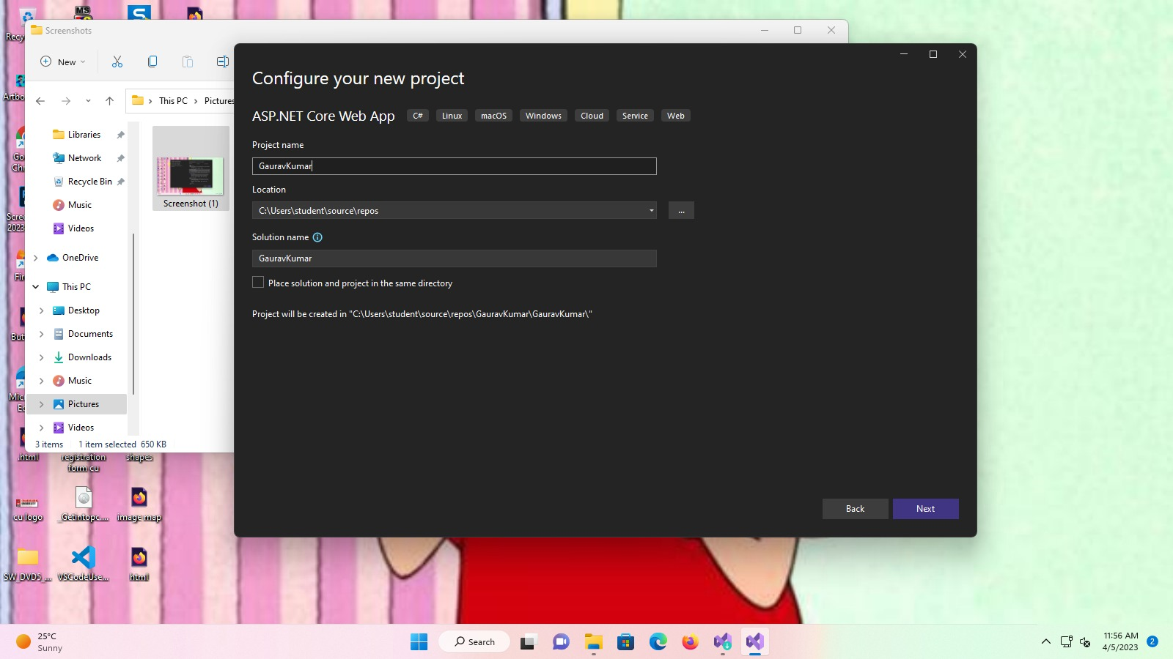

**Step 5)** After that your new project is created edit it according to your needs.

**Step 6)** After finish editing Right click on project and click on build or you can also build your project from build tab from tab bar.

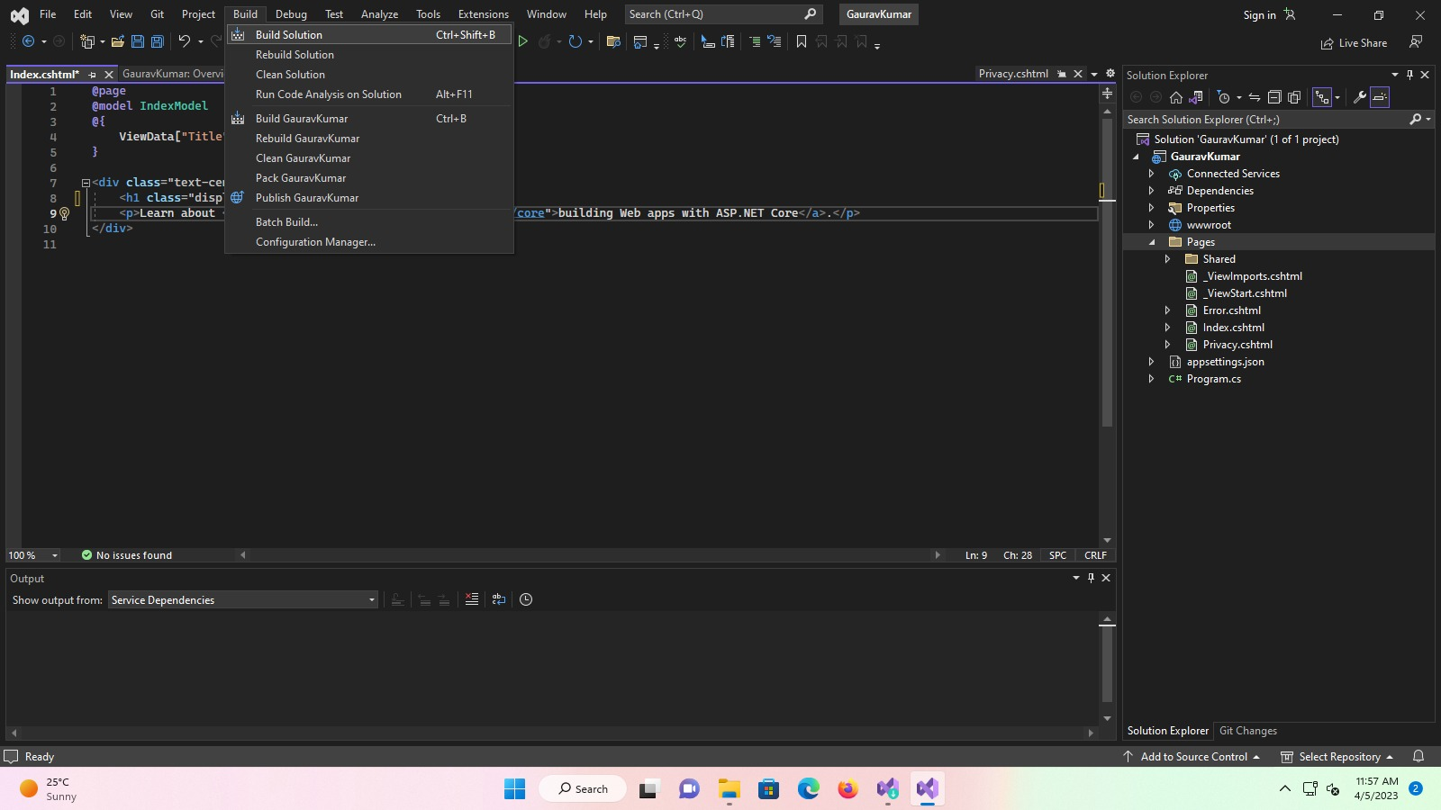

**Step 7)** Once your project builds Successfully. Again, right click on your project name and select **"Publish”.**

**Step 8)** Select **“Azure”** in Target Window. Then click next.

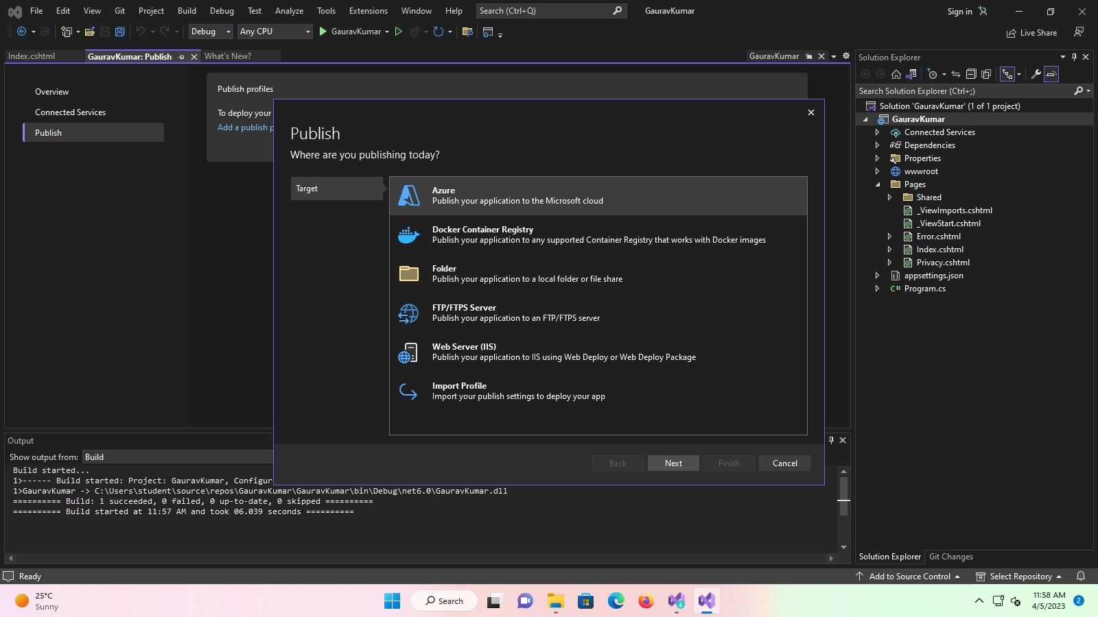

**Step 9)** Select **“Azure app Services (Windows)”** in my case you can choose according to your system requirement. Then click next.

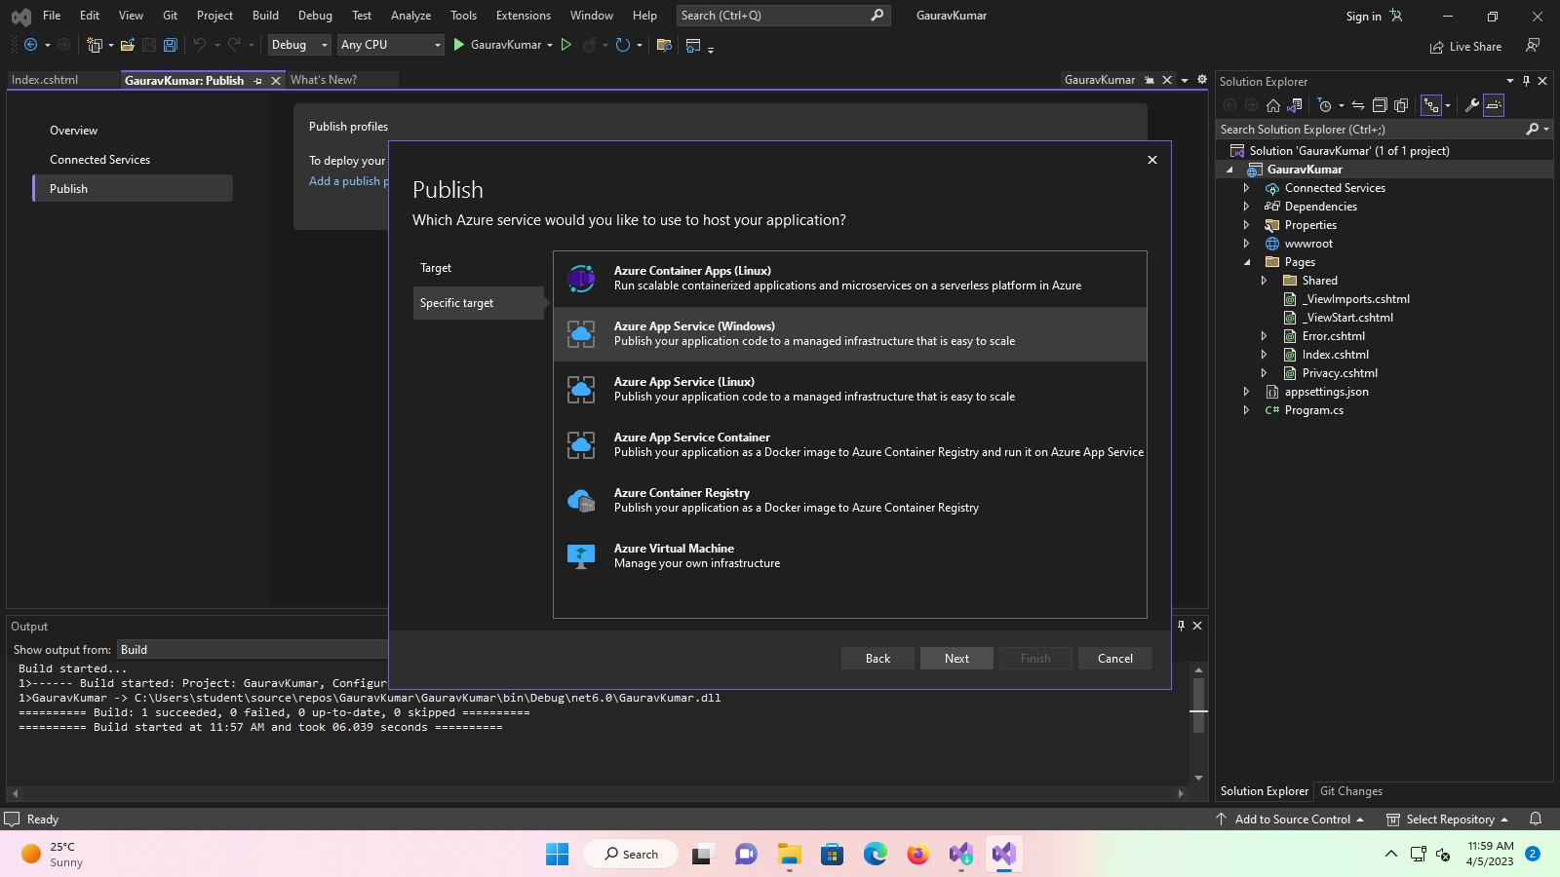

**Step 10)** After that in App Service Window. Select a Resorces if present or create new resource. Then click Finish and close.

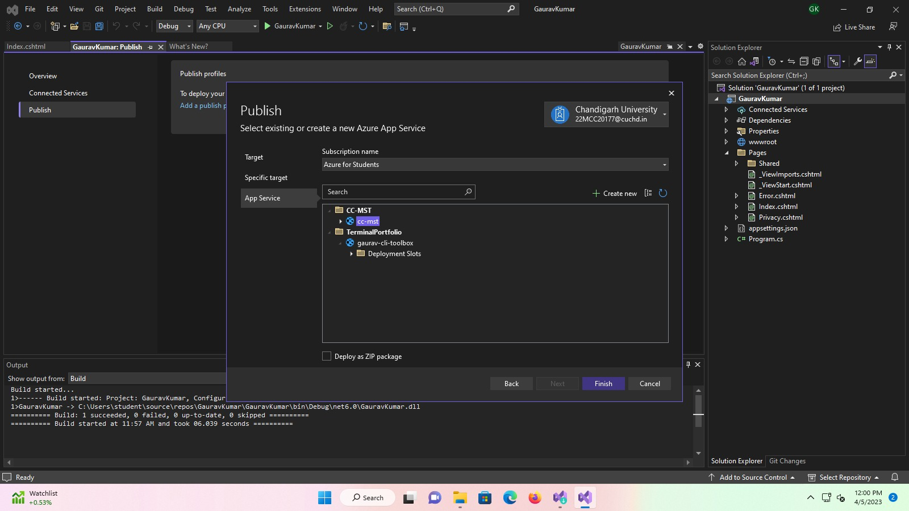

**Step 11)** Once Publish is ready, Click on Publish Button.

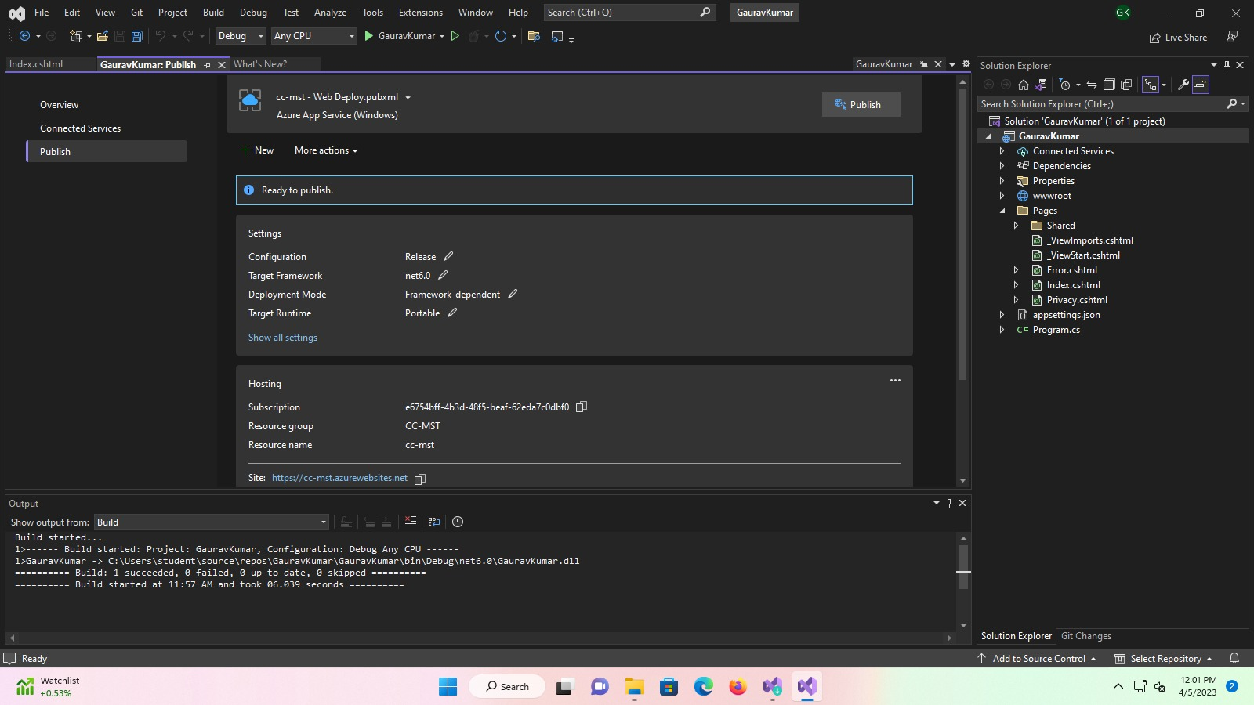

**Step 12)** It will take few seconds to publish your project on Azure Portal and once done you can access your project over the internet.

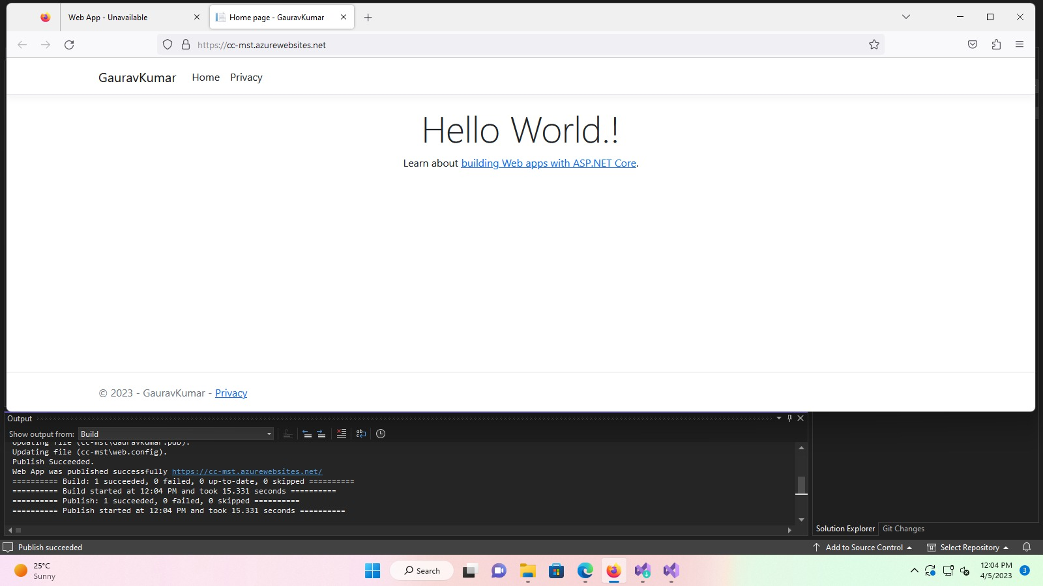

**Learning Outcomes (What I have learned)**

* I Learned to: -
  + - * Create resource in the azure portal.
      * To deploy the web app on the azure portal using Microsoft Visual Studio 2022.

**Evaluation Grid:**

|  |  |  |  |
| --- | --- | --- | --- |
| Sr. No. | Parameters | Marks Obtained | Maximum Marks |
| 1. | Demonstration and Performance  (Quiz) |  | 22 |
| 2. | Worksheet |  | 8 |